Controls System Lab 2 Colin Roskos

An introduction to using matlab to solve differential equations. Using ode45

Conclusion:

The systems below are all non-linear, they all have a sinusoidal shape. The outputs follow the requested example outputs.

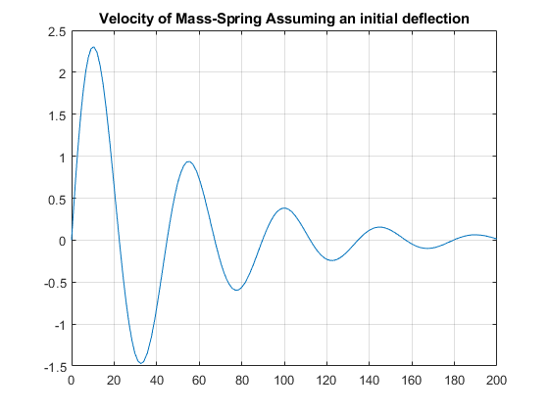

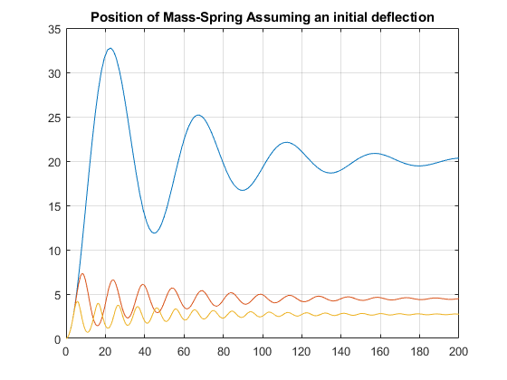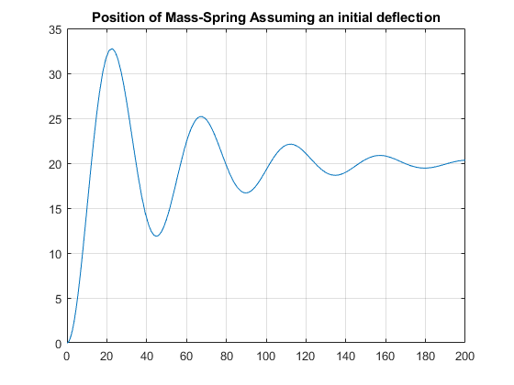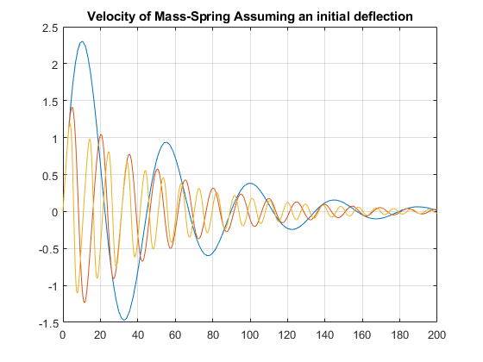

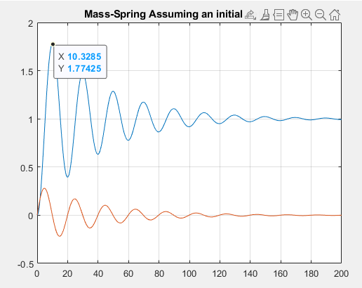

Code:

%% Exercise 1

clear all;

X0 = [0;0];

options = odeset('RelTol',[1e-4 1e-4],'AbsTol',[1e-5 1e-5],'Stats','on');

[t1,X1]=ode45(@(t,X) mass_spring300r1(t,X), [0 200],X0);

[t2,X2]=ode45(@(t,X) mass_spring300r2(t,X), [0 200],X0);

[t3,X3]=ode45(@(t,X) mass_spring300r3(t,X), [0 200],X0);

f1 = figure;

f2 = figure;

figure(f1)

plot(t1,X1(:,1)); hold on;

plot(t2,X2(:,1));

plot(t3,X3(:,1)); grid on; hold off;

title('Position of Mass-Spring Assuming an initial deflection');

figure(f2)

plot(t1,X1(:,2)); hold on;

plot(t2,X2(:,2));

plot(t3,X3(:,2)); grid on; hold off;

title('Velocity of Mass-Spring Assuming an initial deflection');

%% Exercise 2

X0 = [0;0];

options = odeset('RelTol',[1e-4 1e-4],'AbsTol',[1e-5 1e-5],'Stats','on');

[t,X]=ode45(@(t,X) mass_spring1(t,X), [0 200],X0);

figure;

plot(t,X); grid on;

title('Mass-Spring Assuming an initial deflection');

function dXdt=mass_spring300r1(t, X)

%flow rate

M=750; %(Kg)

B=30; %( Nsec/m)

Fa=300; %N

K=15; %(N/m)

r=1;

% dX/dt

dXdt(1,1)=X(2);

dXdt(2,1)=-B/M*X(2)-K/M*X(1)^r+Fa/M;

end

function dXdt=mass_spring300r2(t, X)

%flow rate

M=750; %(Kg)

B=30; %( Nsec/m)

Fa=300; %N

K=15; %(N/m)

r=2;

% dX/dt

dXdt(1,1)=X(2);

dXdt(2,1)=-B/M*X(2)-K/M*X(1)^r+Fa/M;

end

function dXdt=mass_spring300r3(t, X)

%flow rate

M=750; %(Kg)

B=30; %( Nsec/m)

Fa=300; %N

K=15; %(N/m)

r=3;

% dX/dt

dXdt(1,1)=X(2);

dXdt(2,1)=-B/M*X(2)-K/M*X(1)^r+Fa/M;

end

function dXdt=mass_spring1(t, X)

%flow rate

M=10; %(Kg)

B=.5; %( Nsec/m)

Fa=1; %N

K=1; %(N/m)

r=1;

% dX/dt

dXdt(1,1)=X(2);

dXdt(2,1)=-B/M*X(2)-K/M*X(1)^r+Fa/M;

end